# SOP - SRP AdBlocker

**Purpose**: SRP Adblocker is a set of adblocker strategies for sponsored (aka Promoted) listings. Sponsored listings being blocked can impact PLS and [PLA CPC](https://ebayinc.sharepoint.com/sites/ads-sre2/_layouts/OneNote.aspx?id=%2Fsites%2Fads-sre2%2FSiteAssets%2Fads-sre%20Notebook&wd=target%28KB%2FBusiness%20Principle.one%7CF926CECB-5611-4A40-B837-A72D24A7278A%2FPLA%20CPC%7C1F189B4D-96C3-4179-9B1D-2CC96F1E1388%2F%29%20onenote:https://ebayinc.sharepoint.com/sites/ads-sre2/SiteAssets/ads-sre%20Notebook/KB/Business%20Principle.one#PLA%20CPC&section-id={F926CECB-5611-4A40-B837-A72D24A7278A}&page-id={1F189B4D-96C3-4179-9B1D-2CC96F1E1388}&object-id={CC76B4AD-A060-468B-917D-4A92D93AEB85}&D) business metrics.

The "Sponsored" badge on item card can be rendered in multiple ways. Each way of rendering the badge is called a strategy. The motivation for enabling multiple strategies is to overcome ad blockers from detecting and removing these items on the page.

# Contacts:

Search Experience Team PagerDuty <https://ebay-cpt.pagerduty.com/service-directory/PNXCM3Y>

PD On-Call: Click, Jack **Please check their PagerDuty for an ack'd alert first as they have their own sets of alerts + PD notifications separate from our channel.  Ack'd = they're aware & likely working on it.**

When notifying, also ping to slack #cpa_search_product_analytics, [DL-eBay-AdBlocker-Tracking@](mailto:DL-eBay-AdBlocker-Tracking@ebay.com)ebay.com (Analysts + Ads Infra)

## Search Owned Rules

<https://cloud.ebay.com/rule-groups/rg/srpnweb_test_custom_rule_group?env=production>

Dashboard: <http://cassiniacemetrics.vip.ebay.com/d/btAu4wc7z/srp-adblocker-monitoring-dashboard?orgId=1&refresh=1m&from=now-6h&to=now&var-siteId=0>

Strategies Definition: <https://github.corp.ebay.com/SFE/search_node/blob/master/src/fe-components/s-item/details/sponsored/strategies/README.md>

Framework: AdBlocker Mitigation Framework

Usual Cause is Adblocker filters such as Adblock Plus: <https://github.com/abp-filters/abp-filters-anti-cv>

## Ads Owned Rules

<https://cloud.ebay.com/rule-groups/rg/srpnweb_adblocker_ads?env=production&ug=ads_infra>

* CORE Sites P2 :
  + SRP_adblocker_strategy0_core
  + SRP_adblocker_strategy1_core
  + SRP_adblocker_strategy2_core
  + SRP_adblocker_strategy3_core
  + SRP_adblocker_strategy4_core
  + SRP_adblocker_strategy5_core
  + SRP_adblocker_strategy6_core
  + Query Sample:

sum(rate(srpnweb_pl_strategy_1{_namespace_="srpnweb",component="dweb",siteId=~"0|2|3|15|77"}[2m])) by (siteId) / sum(rate(srpnweb_req_total{_namespace_="srpnweb",component="dweb",siteId=~"0|2|3|15|77"}[2m])) by (siteId)> 0.01

CORE: US=0, UK=3, AU=15, DE=77 + CA=2 Site ID and Site URL for Countries

### ****Action to Take -****

* + 1. Check if it is a known issue, often communicated by Click, Jack
       1. **Check Search Experience Team's** [**PagerDuty**](https://ebay-cpt.pagerduty.com/service-directory/PNXCM3Y) current on-call for recent matching Incident "Adblock Strategy # breached" - **If it is ack'd then they're actively working on it. We don't need to reach out.  Jack's team will send an update via e-mail or slack #cpa_search_product_analytics**, usually within the same day
       2. Is the condition still alerting and not marked as resolved?  This indicates the issue is still active.

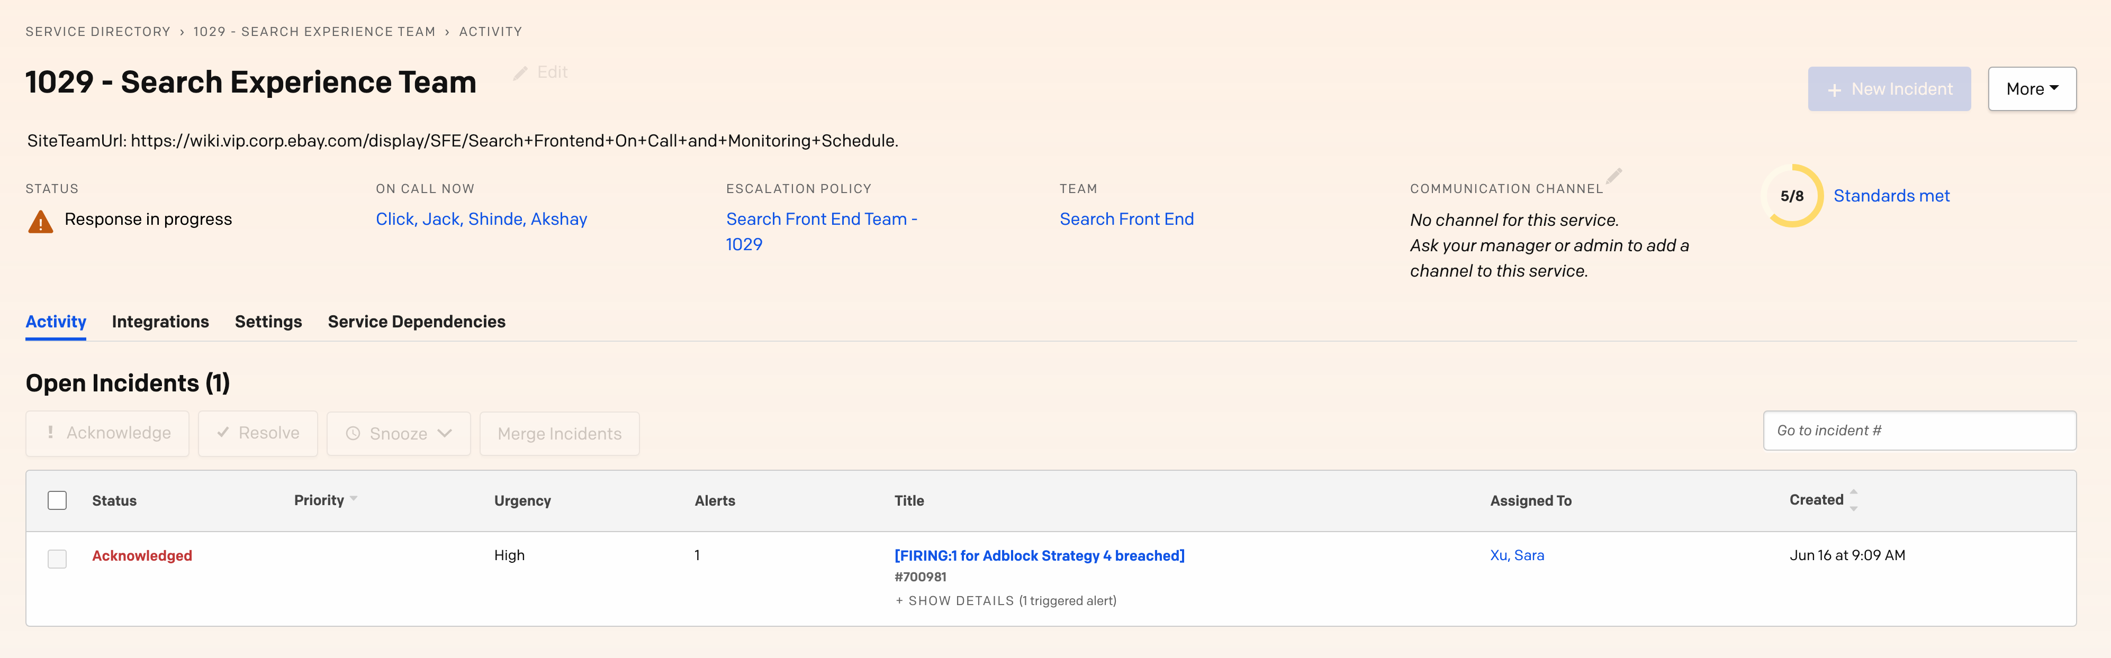

* + - 1. If there is no PagerDuty, check their setup alert thresholds and siteId dimensions, view the dashboard by siteId which is alerting: <http://cassiniacemetrics.vip.ebay.com/d/btAu4wc7z/srp-adblocker-monitoring-dashboard?orgId=1&refresh=1m&from=now-6h&to=now&var-siteId=0>
    1. If alerting and there is an Incident but no related communication from Search/Ads Analysts & not in Ads Infra on-call shift handoff, email Click, Jack  & cc [DL-eBay-AdBlocker-Tracking@ebay.com](mailto:DL-eBay-AdBlocker-Tracking@ebay.com) to keep us in the loop for issue and ETA for resolution.  This is also so we can build knowledge for Merch AdBlocker improvements & ops.
    2. Lower-priority If alerting for site!=0,3,77 and site=0,3,77 looks ok, reach out on slack and cc Click, Jack .  They monitor siteId=0,3,77 for PagerDuty, in the unusual case that it is site specific & doesn't impact core revenue sites
* Non-Core Sites P3:
  + SRP_adblocker_strategy0_noncore
  + SRP_adblocker_strategy1_noncore
  + SRP_adblocker_strategy2_noncore
  + SRP_adblocker_strategy3_noncore
  + SRP_adblocker_strategy4_noncore
  + SRP_adblocker_strategy5_noncore
  + SRP_adblocker_strategy6_noncore
  + Query Sample:

sum(rate(srpnweb_pl_strategy_1{_namespace_="srpnweb",component="dweb",siteId!~"0|2|3|15|77"}[2m])) by (siteId) / sum(rate(srpnweb_req_total{_namespace_="srpnweb",component="dweb",siteId!~"0|2|3|15|77"}[2m])) by (siteId)> 0.01

* + Action to Take
    1. Check their setup alert thresholds and siteId dimensions, view the dashboard by siteId which is alerting: <http://cassiniacemetrics.vip.ebay.com/d/btAu4wc7z/srp-adblocker-monitoring-dashboard?orgId=1&refresh=1m&from=now-6h&to=now&var-siteId=0>
    2. Notify on-call engineer via e-mail

<https://cloud.ebay.com/rule-groups/rg/srpnweb_adblocker_ads_daily?env=production&ug=ads_infra>

* SRP_adblocker_new_strategy_added - daily check for known strategies0-6 and no others added.  If a new strategy & strategy metric is [added](https://github.corp.ebay.com/SFE/search_node/blob/master/src/fe-components/s-item/details/sponsored/strategies/README.md) then corresponding alerts must also be added.  We may not be informed or watching all the git repo changes on the active repo, so this is just a way for us to be informed.